Course Project - Inserting Large Data Sets

Shaun Pritchard

Rasmussen College

QMB4200

Terry Brookhouser

October 22, 2020

As an ETL developer I needed to migrate one of the existing **features** dataset 12. I also loaded the demo data from class in this report as well.

I created a database table and name it as **Feature** table and migrate data from all CSV files. Creating a single SSIS package to loop through the CSV file one by one and migrated it into the Azure cloud database table.

My Submission:

* Submit SSIS Package (included with file)
* Screenshot of SSIS package
* Screenshot of database table output

**Screenshot of SSIS package**

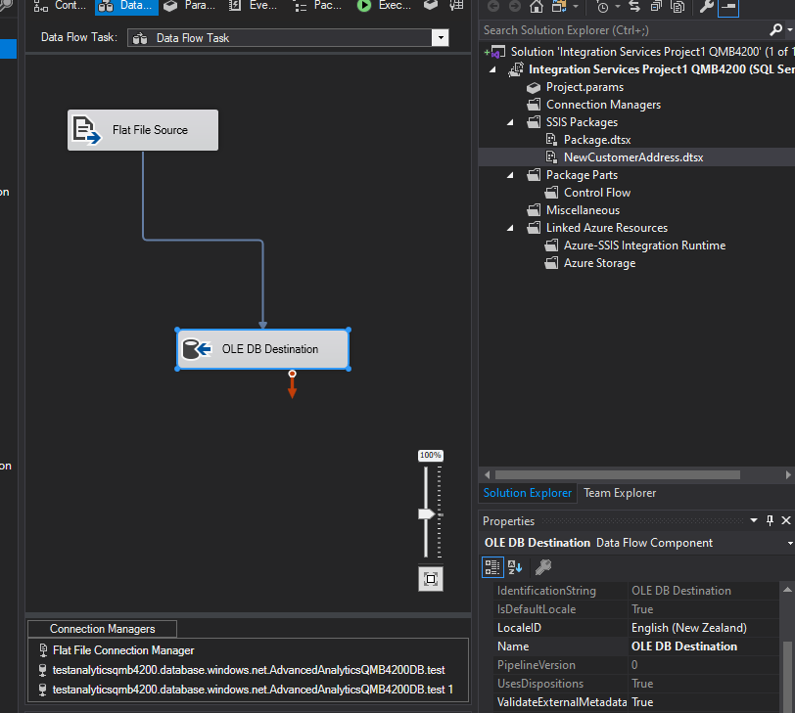

**Screenshot of database table output**

I changed the datatype to unsigned integer for the ***customerID***

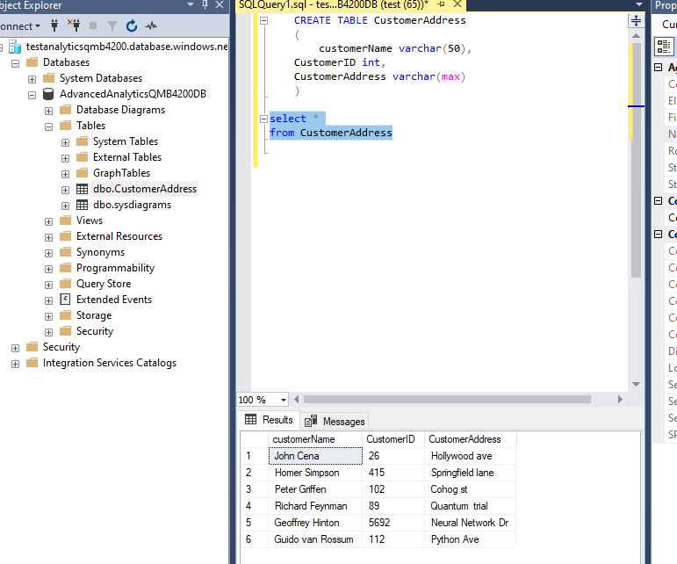

**Screenshots of the Feature Data SET**

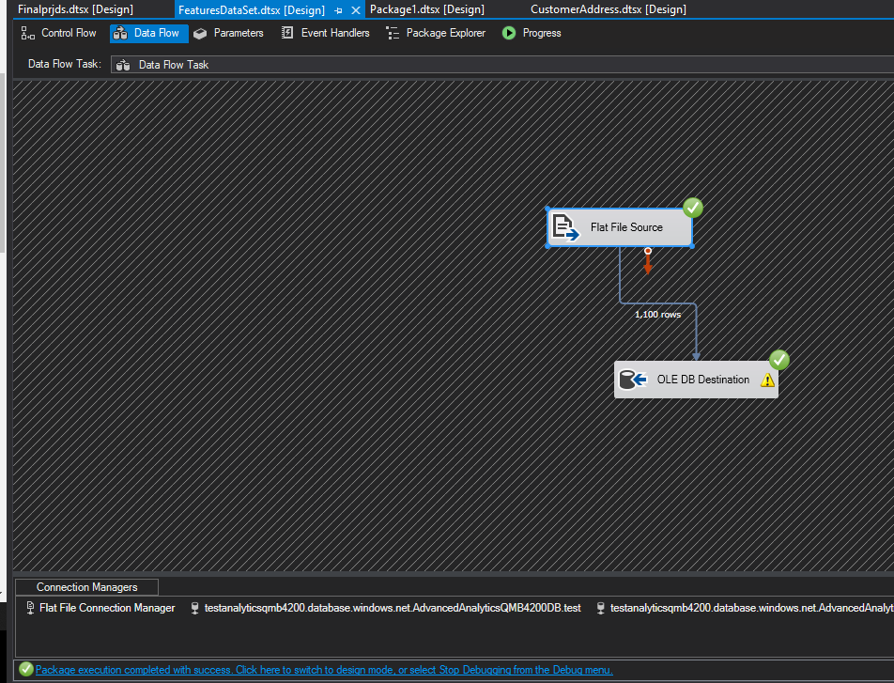

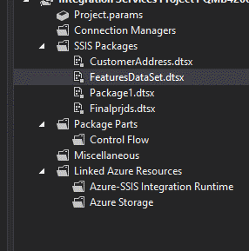

**SQL Queries:**

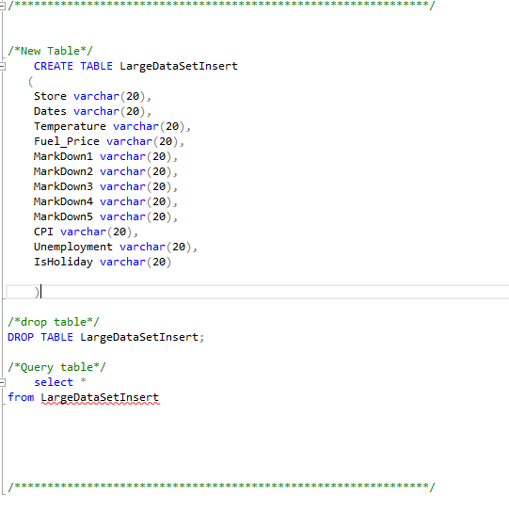

**Output table data stored on Azure cloud:**

I changed the Dates column to the DATE datatype, but I still get this null result?

